Microprocessors

Mammal
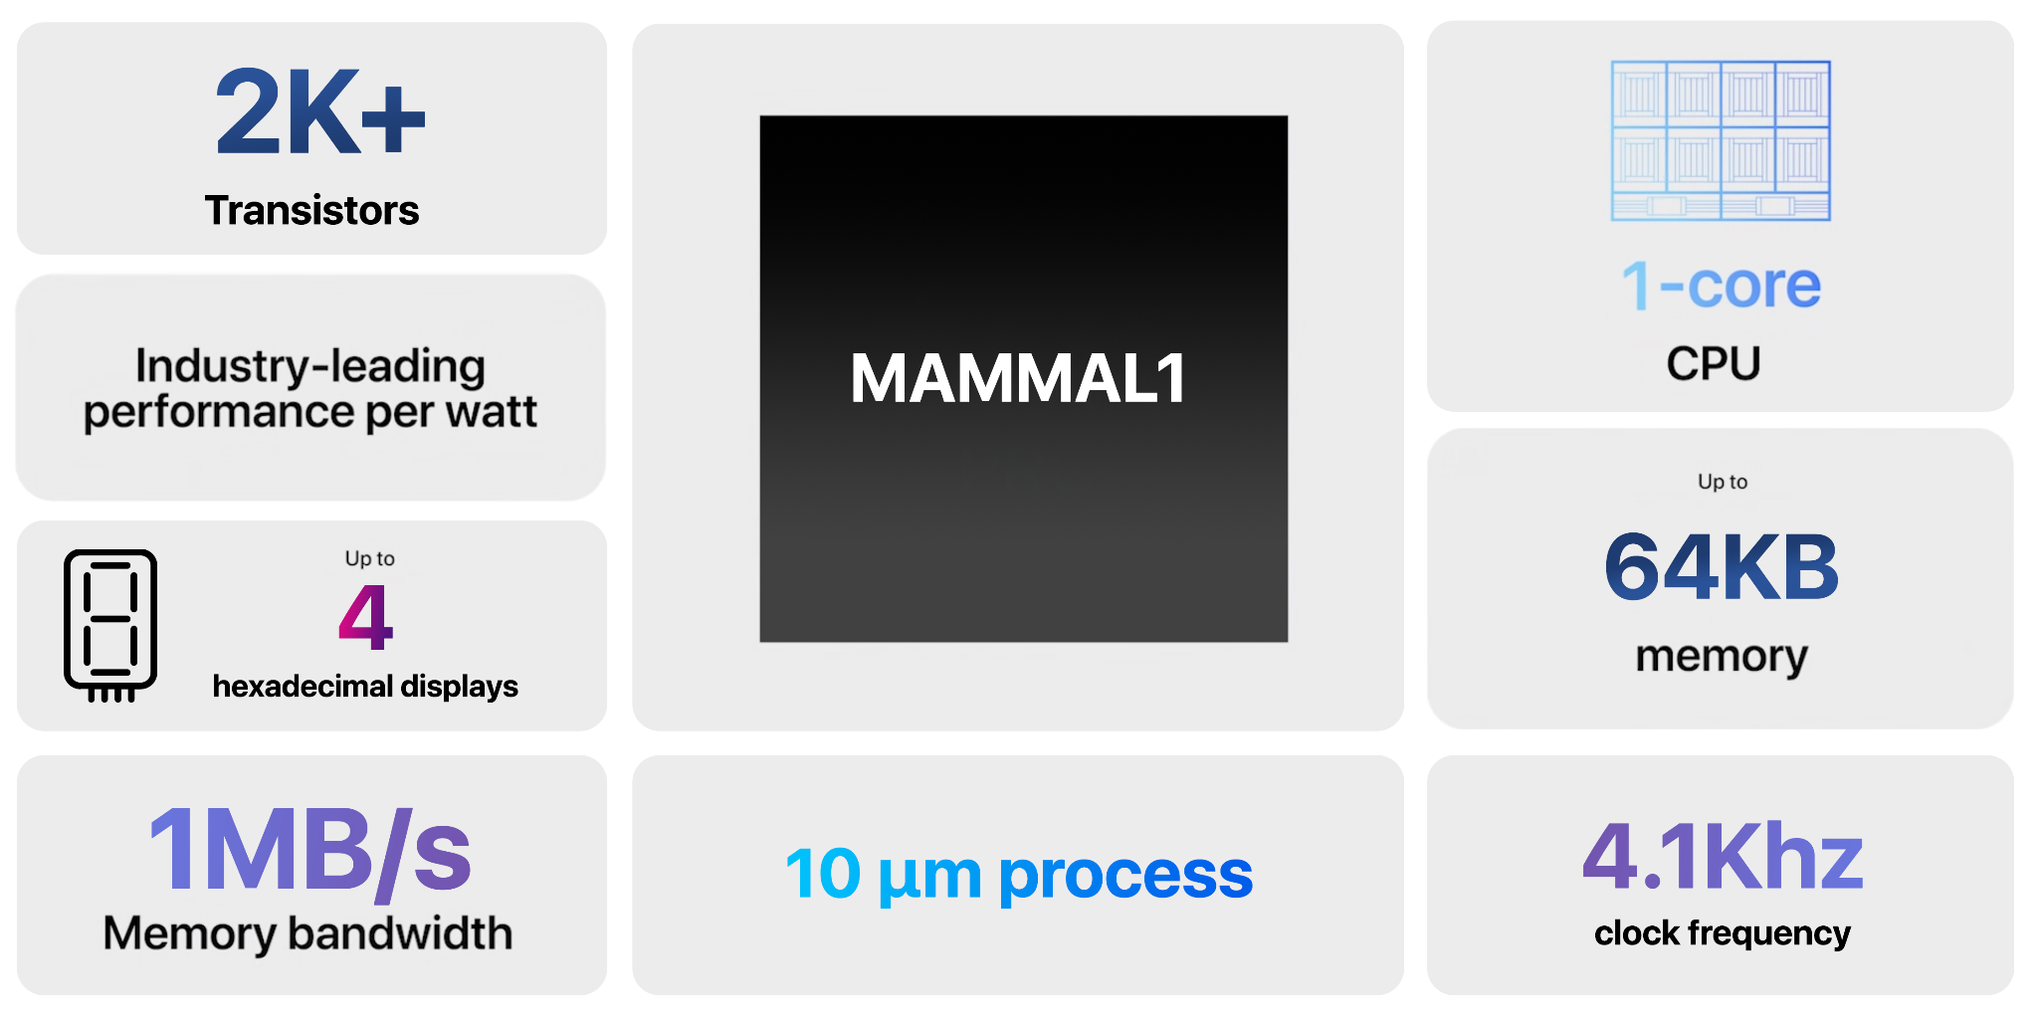

Finite State Machine
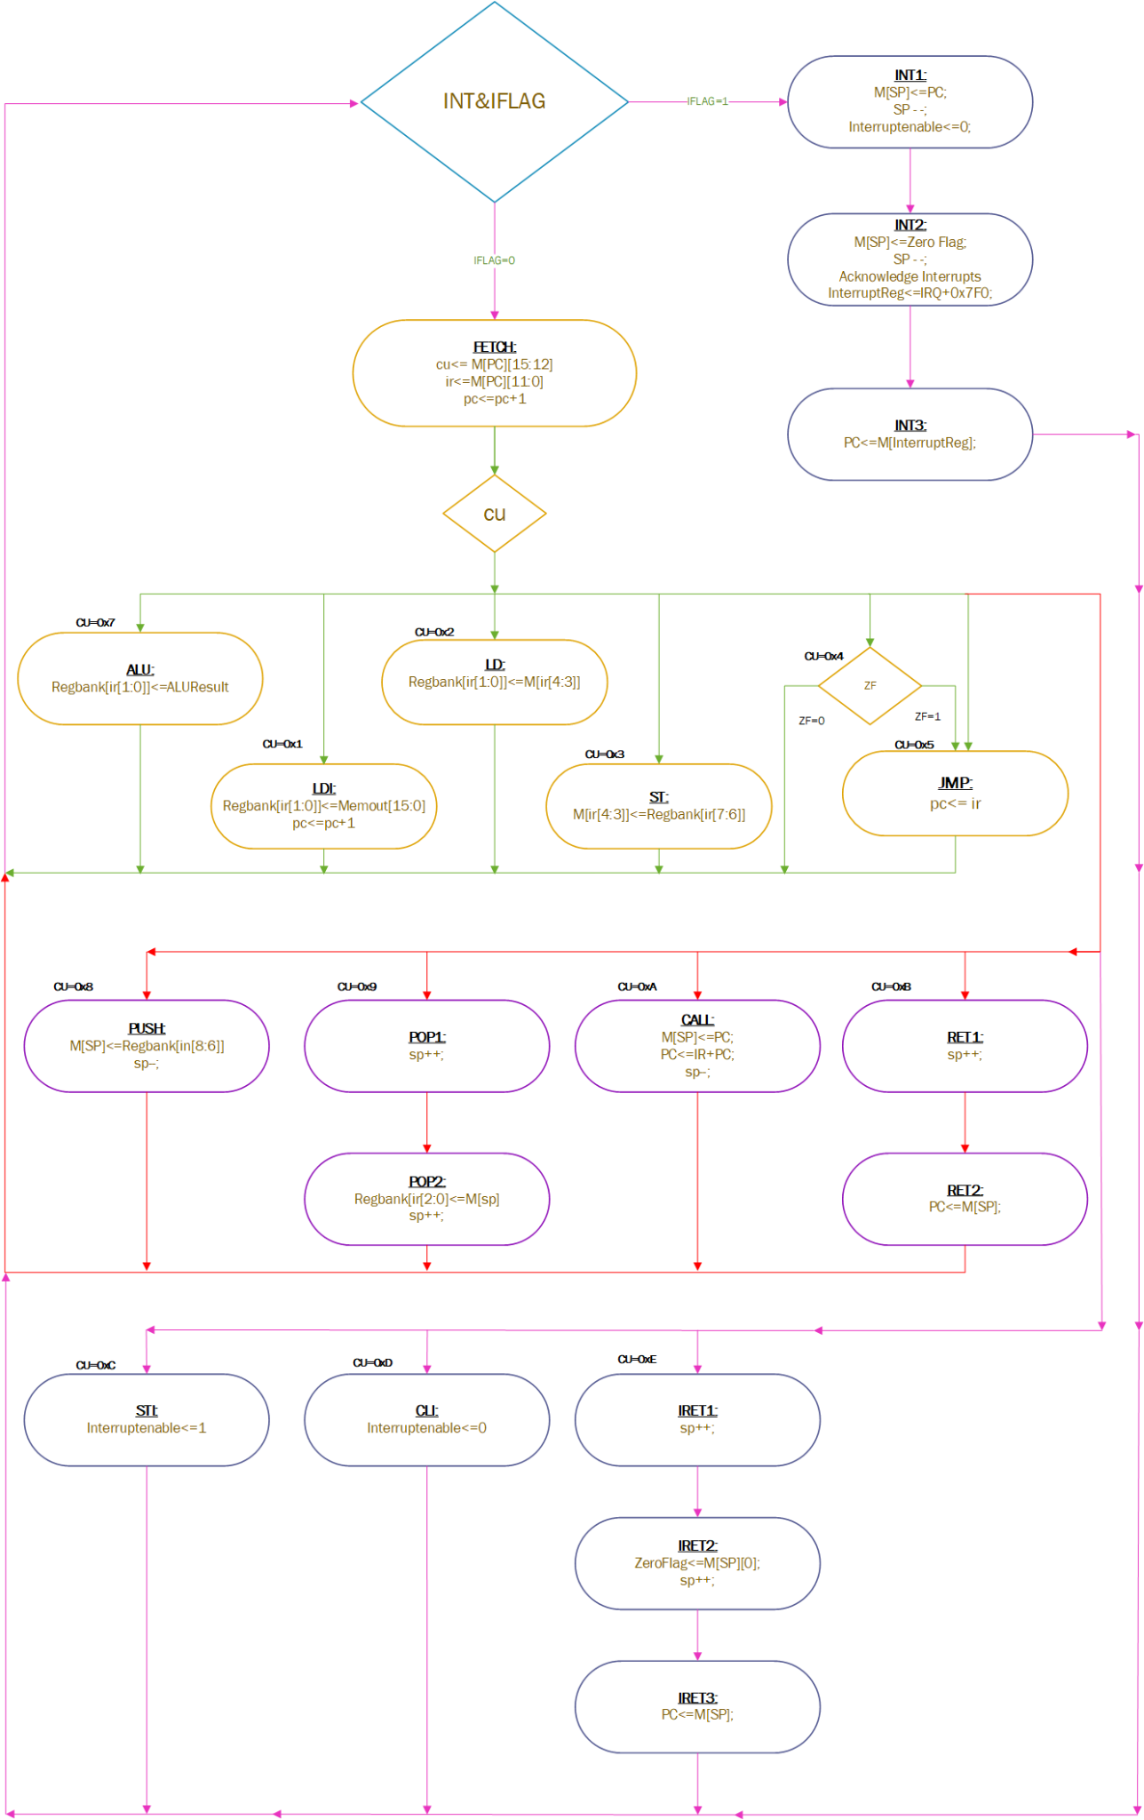

Control Signals
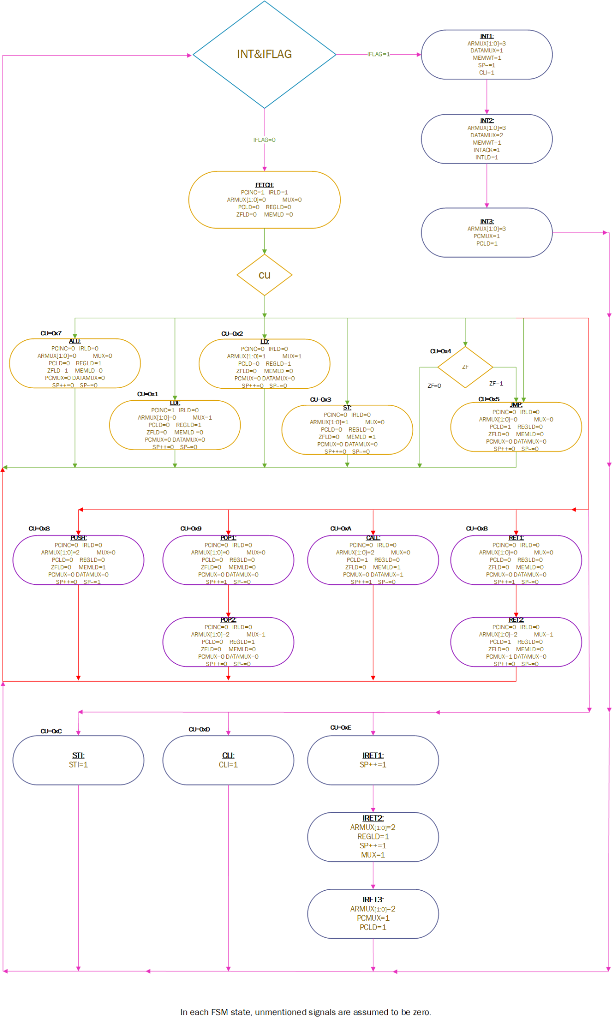
STI=IFSET, CLI=IFRESET

Hardware with Control Unit
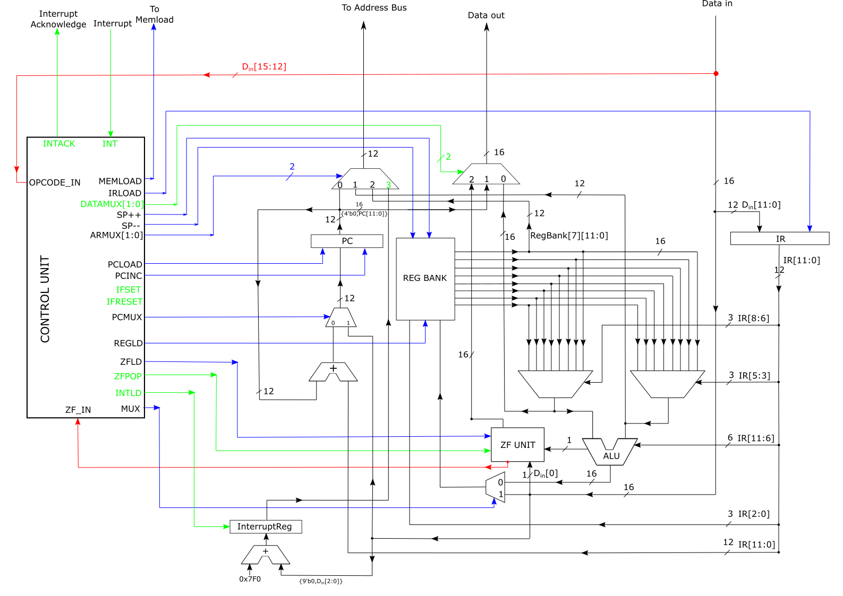

Control Unit
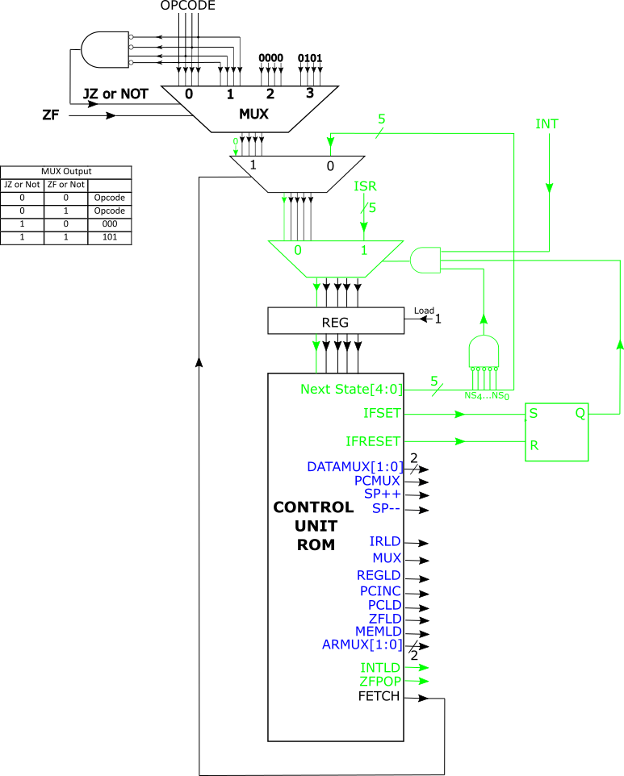

ZF Unit
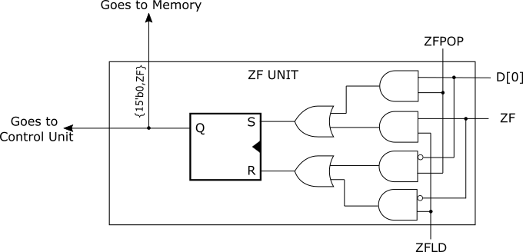

Hardware Design
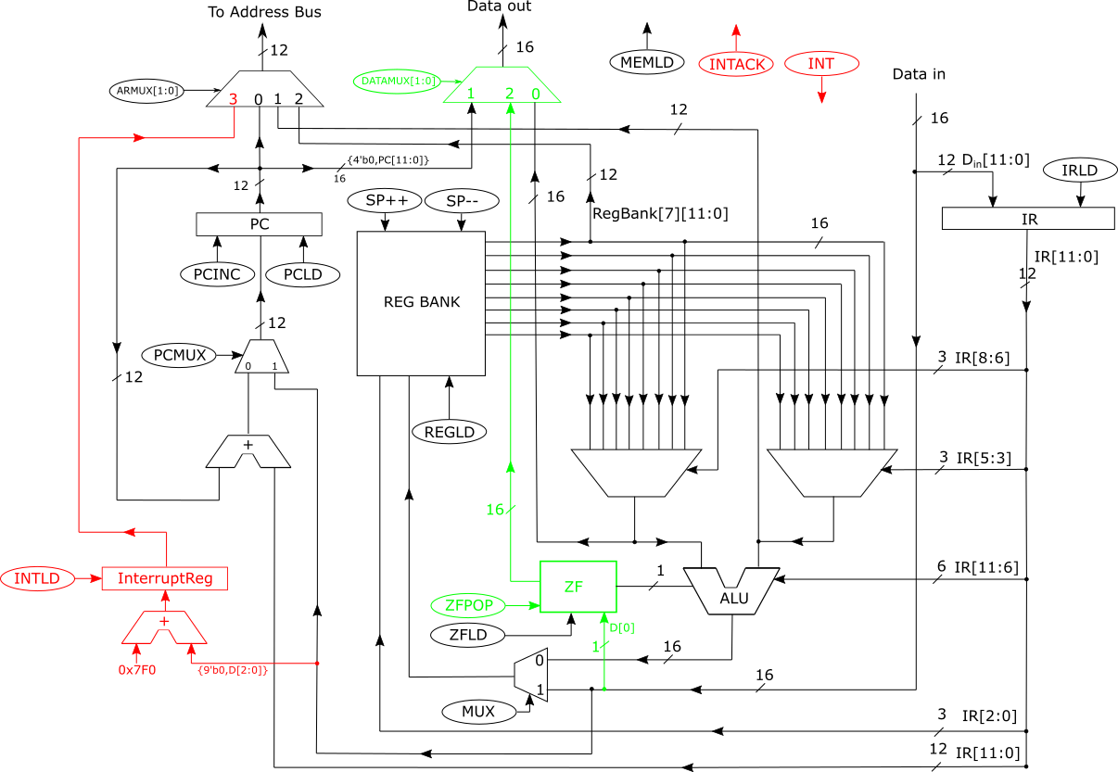

Instruction Set

LD
Load instruction transfers
- the contents of a memory location (which is a 16-bit number)
- into a register of Reptile.
The assembly format of the Load instruction is as follows:
LD r1 r2
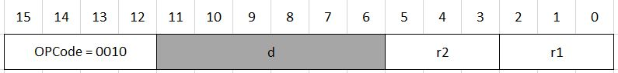

LDI
LDI r,x
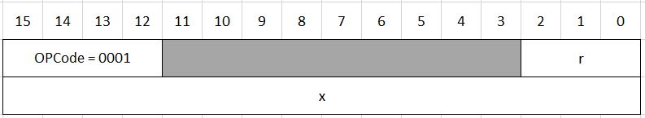

ALU Instructions

Instruction Format

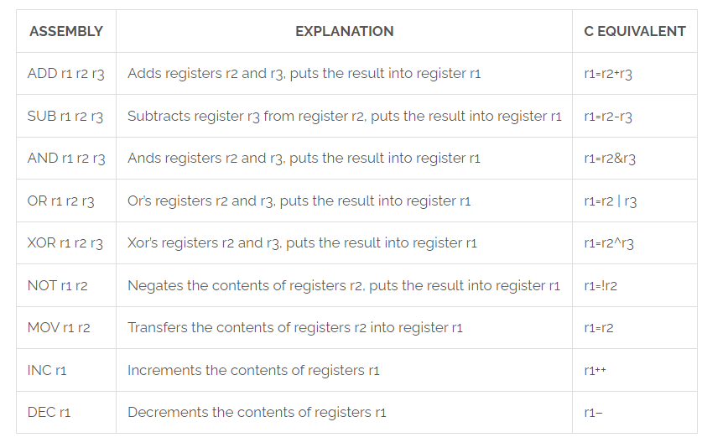

ALU Codes

Instruction | ALU CODE
ADD | 0000
SUB | 0001
AND | 0010
OR | 0011
XOR | 0100
NOT | 0101
MOV | 0110
INC | 0111
DEC | 1000

INC
INC r1
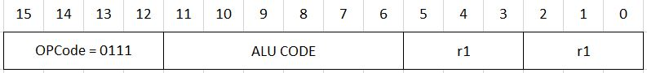

DEC
DEC r1

MOV
MOV r1 r2
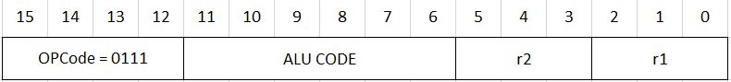

NOT
NOT r1 r2

ADD, SUB, AND, OR, XOR
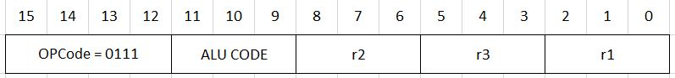

JUMP
JMP instruction is unconditional: it always jumps to the given target location within the code
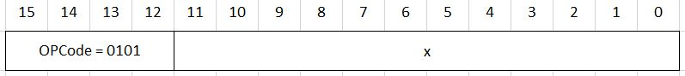

JZ
JZ instruction is conditional: it jumps to the given target location within the code only if the result of the last ALU instruction is zero. Otherwise, the next instruction in the program is executed.
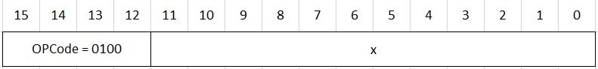

ST
Store instruction stores
- The contents of a register
- Into a memory location, which is pointed by another register.
The assembly format of the Store instruction is as follows:
ST r1 r2
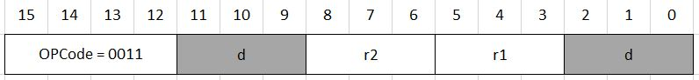
Here r1 and r2 are two-bit fields denoting two registers:
- r1 is a register which “points” to memory: It contains the address of the memory location to which the data is to be loaded .
- r2 is the register which contains the data to be stored in memory.

PUSH
Assembly format: Push r
Writes the contents of the register r into the memory location pointed by the SP. Then decrements SP by one.
Machine code format:
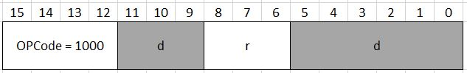

POP
Assembly format: Pop r
Pop increments SP by 1, then transfers the content of the memory location pointed by SP into register r.
Machine code format:
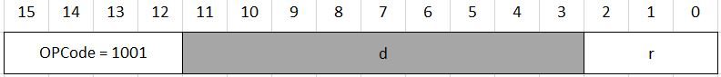

CALL
Assembly format: Call x
Pushes the content of the Program Counter (PC) into the stack and jumps to memory address PC+x, i.e, loads the number PC+x into PC. (PC<=PC+x). Recall that PC is already incremented when we start to execute the Call instruction.
Machine code format:
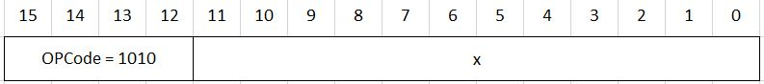

RET
Assemby format: Ret
Pops the top of the stack into PC.
Machine code format:
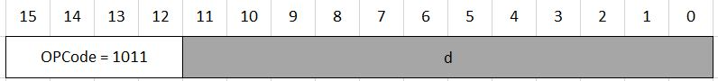

IRET
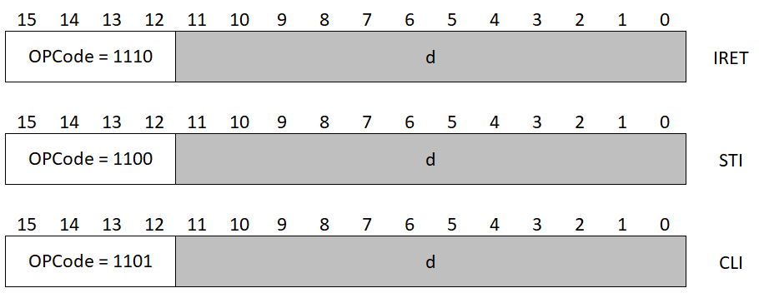

STI

CLI

Bird

Finite State Machine
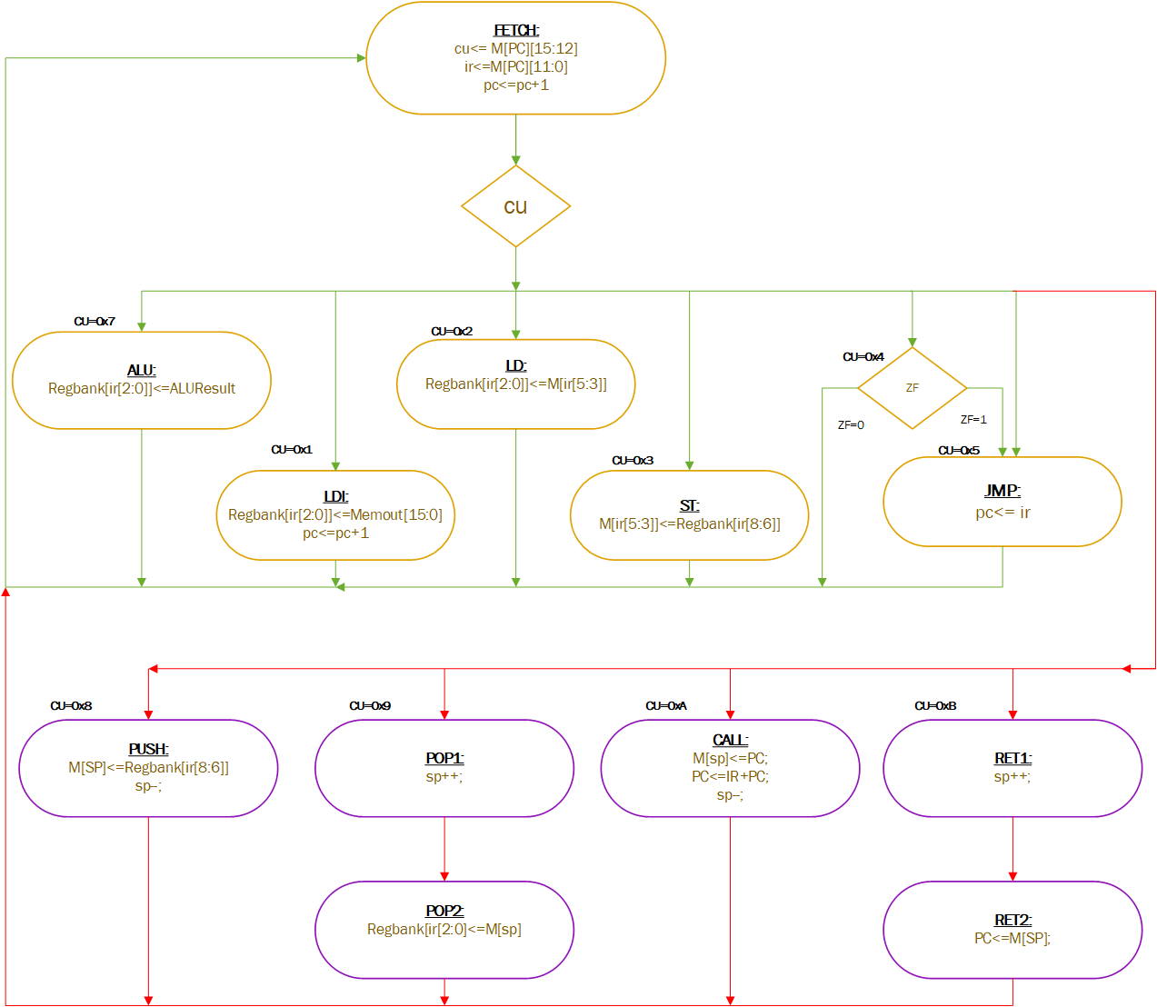

Hardware Design
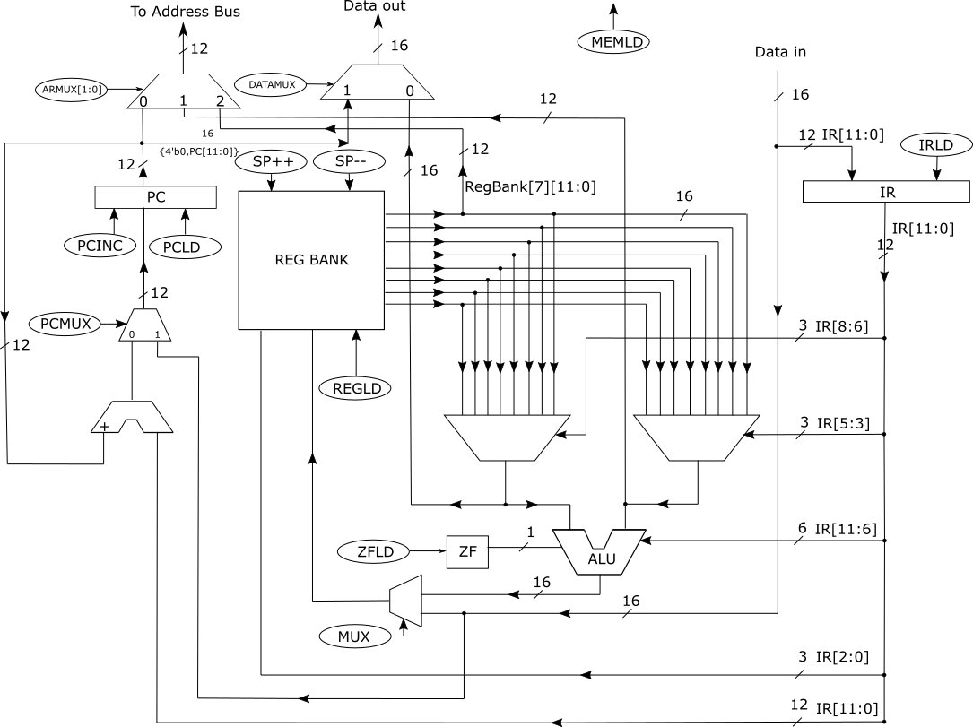

Control Unit Connection
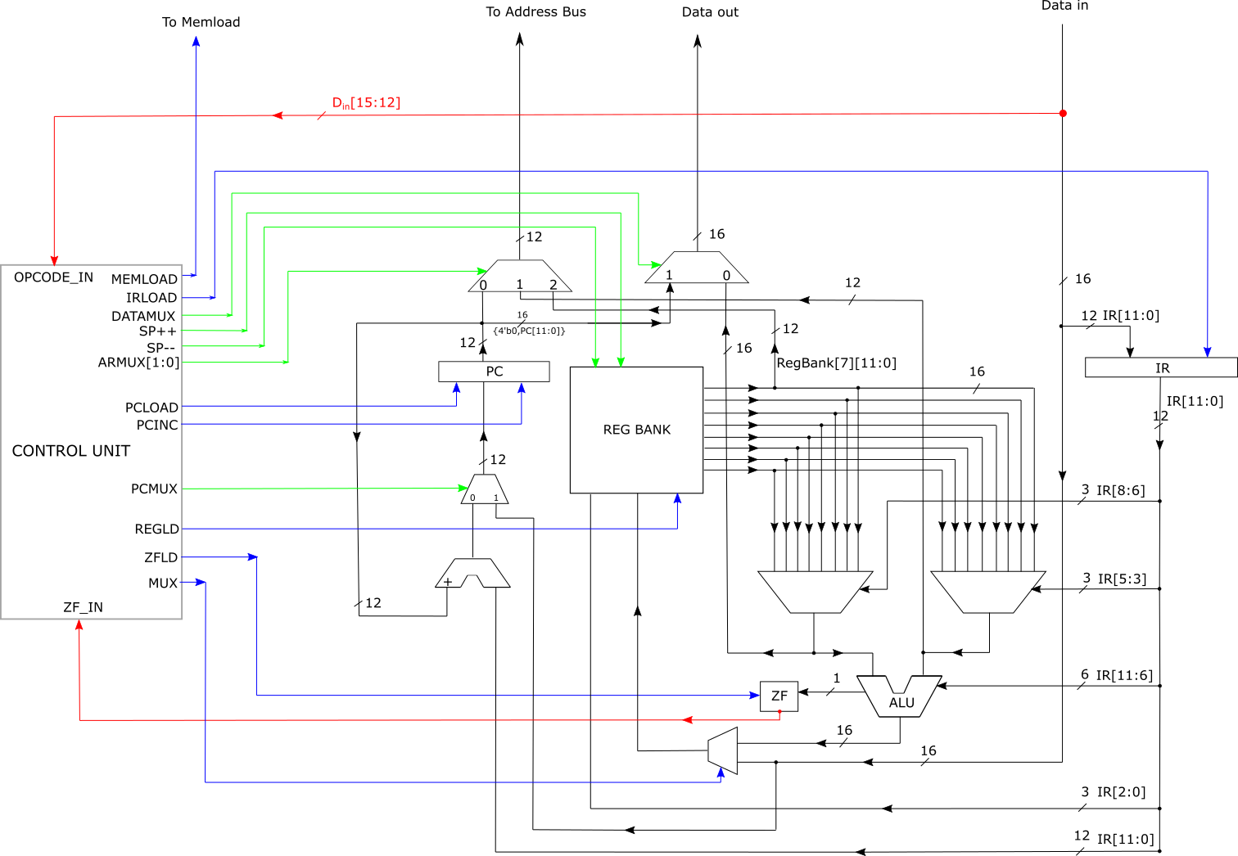

Control Unit Interior
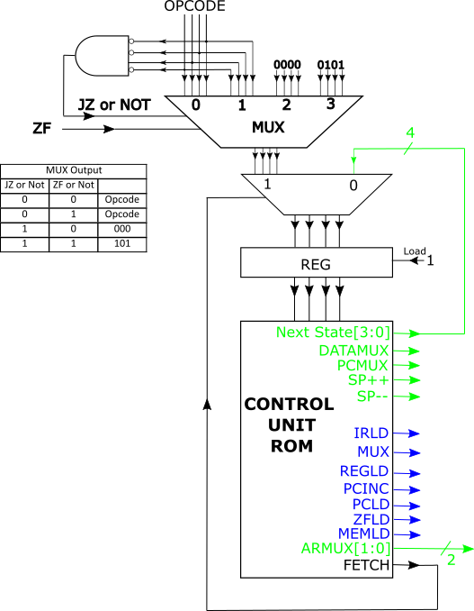

Control Signals
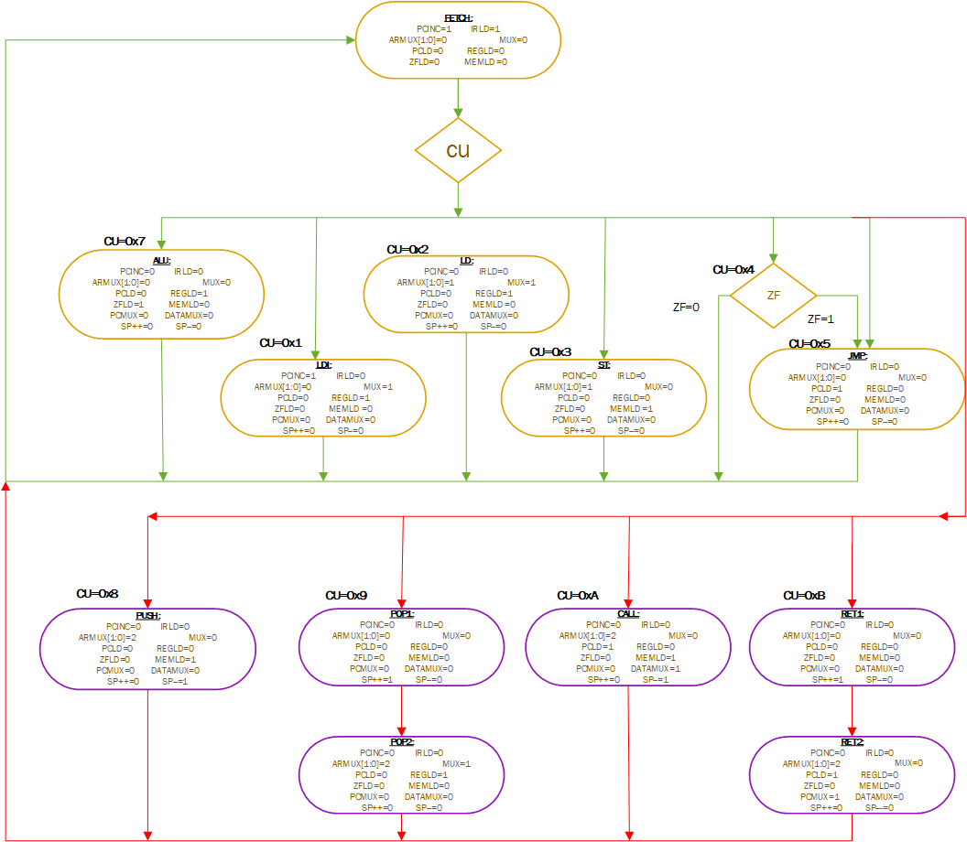

Microcode
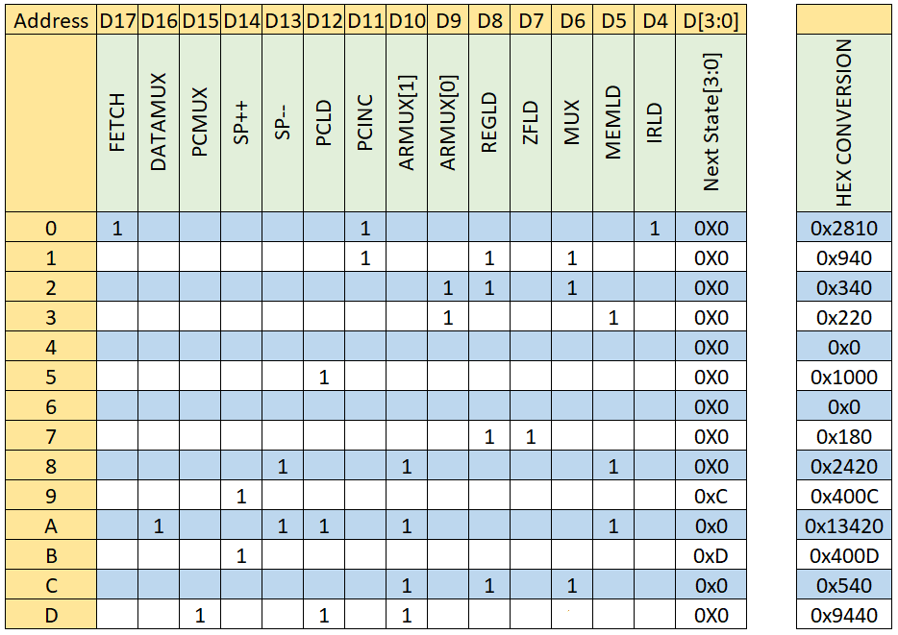

Register Bank
